**Question A – Daniyar Nazarbayev, H00204990.**

**1.**

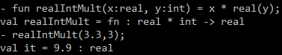

**2.**

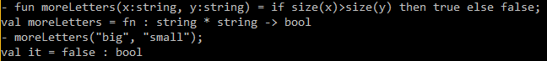

**3.**

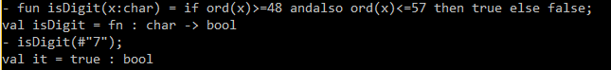

**4.**

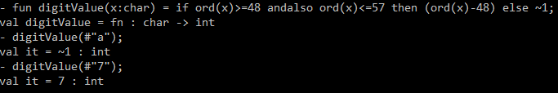

**5.**

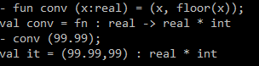

**6.**

